Assignment
1) Handle the table in https://demoqa.com/webtables and display the output

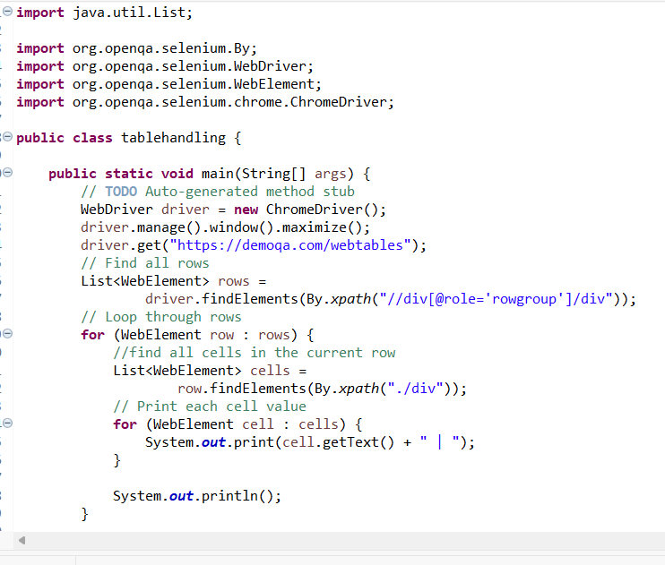

“First I locate all the rows of the web table. Then I iterate through each row and locate all the cells inside that row. Finally, I use getText() to retrieve and display the cell values.”

- 2) https://demoqa.com/text-box : Click the "Submit" button with reference to "Permanent Address" by using Relative Locators
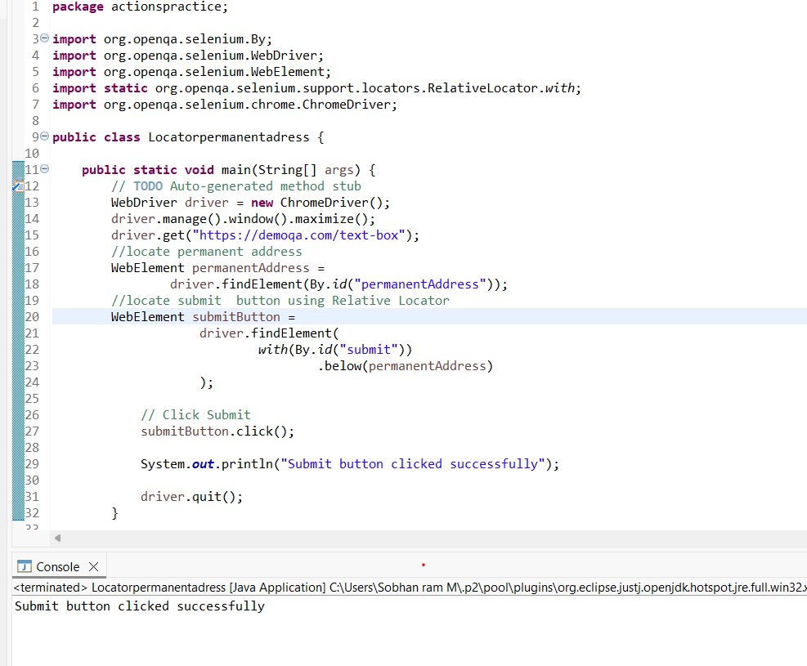
“I used Selenium 4 Relative Locator. First, I located the Permanent Address text box using its ID. Then I used the below() relative locator to identify the Submit button relative to the Permanent Address field, and finally I clicked the button.”

